­­

Residuos medicales Bolsas de plástico

Basura Espejos

Residuos de césped Juguetes de plástico

Pyrex o cerámicos Cajas de pizza

Vidrio cilindrado Papel de aluminio

Bombillas Electrónicos

Styrofoam Residuos peligrosos

**No se puede reciclar:**

**Sí se puede reciclar:**

Periódicos Envases plasticos #1-7

Correo jonque Botellas de vidrio

Papel de oficína Jarras de vidrio

Revistas Latas de aluminio

Libros de telefono Latas de acero

Cartulina aplastada Papel triturado

Cajas de cereal y galletas Insertas de periódicos

|  |  |  |  |  |  |  |
| --- | --- | --- | --- | --- | --- | --- |
| Febrero | | | | | | |
| Do | Lu | Ma | Mi | Je | Fi | Sa |
|  |  |  | 1 | 2 | 3 | 4 |
| 5 | 6 | **7** | 8 | 9 | 10 | 11 |
| 12 | 13 | 14 | 15 | 16 | 17 | 18 |
| 19 | 20 | **21** | 22 | 23 | 24 | 25 |
| 26 | 27 | 28 |  |  |  |  |

|  |  |  |  |  |  |  |
| --- | --- | --- | --- | --- | --- | --- |
| Agosto | | | | | | |
| Do | Lu | Ma | Mi | Ju | Vi | Sa |
|  |  | 1 | 2 | 3 | 4 | 5 |
| 6 | 7 | **8** | 9 | 10 | 11 | 12 |
| 13 | 14 | 15 | 16 | 17 | 18 | 19 |
| 20 | 21 | **22** | 23 | 24 | 25 | 26 |
| 27 | 28 | 29 | 30 | 31 |  |  |
|  |  |  |  |  |  |  |

¿Preguntas sobre lo que se puede y no se puede reciclar?

Llame a Waste Industries Recycling al (336) 229-0525

2017

**PUEBLO DE HAW RIVER**

**INFORMACION DE RECICLAJE**

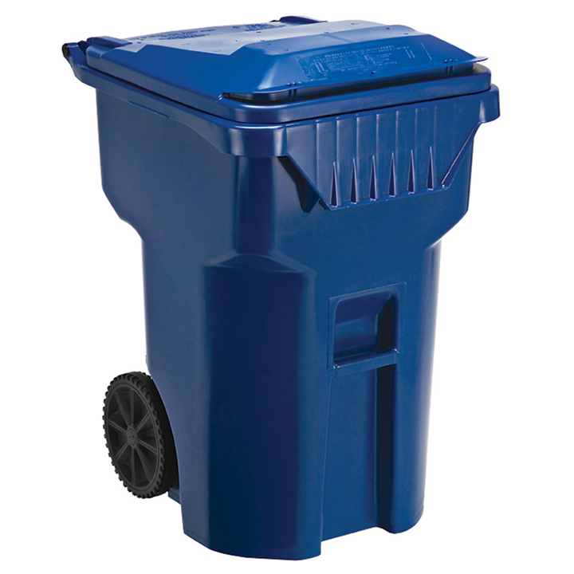



|  |  |  |  |  |  |  |
| --- | --- | --- | --- | --- | --- | --- |
| Enero | | | | | | |
| Do | Lu | Ma | Mi | Ju | Vi | Sa |
| 1 | 2 | 3 | 4 | 5 | 6 | 7 |
| 8 | 9 | **10** | 11 | 12 | 13 | 14 |
| 15 | 16 | 17 | 18 | 19 | 20 | 21 |
| 22 | 23 | **24** | 25 | 26 | 27 | 28 |
| 29 | 30 | 31 |  |  |  |  |
|  |  |  |  |  |  |  |

|  |  |  |  |  |  |  |
| --- | --- | --- | --- | --- | --- | --- |
| Mayo | | | | | | |
| Do | Lu | Ma | Mi | Ju | Vi | Sa |
|  | 1 | **2** | 3 | 4 | 5 | 6 |
| 7 | 8 | 9 | 10 | 11 | 12 | 13 |
| 14 | 15 | **16** | 17 | 18 | 19 | 20 |
| 21 | 22 | 23 | 24 | 25 | 26 | 27 |
| 28 | 29 | **30** | 31 |  |  |  |
|  |  |  |  |  |  |  |

|  |  |  |  |  |  |  |
| --- | --- | --- | --- | --- | --- | --- |
| Julio | | | | | | |
| Do | Lu | Ma | Mi | Ju | Vi | Sa |
|  |  |  |  |  |  | 1 |
| 2 | 3 | 4 | 5 | 6 | 7 | 8 |
| 9 | 10 | **11** | 12 | 13 | 14 | 15 |
| 16 | 17 | 18 | 19 | 20 | 21 | 22 |
| 23 | 24 | **25** | 26 | 27 | 28 | 29 |
| 30 | 31 |  |  |  |  |  |

|  |  |  |  |  |  |  |
| --- | --- | --- | --- | --- | --- | --- |
| Octubre | | | | | | |
| Do | Lu | Ma | Mi | Ju | Vi | Sa |
| 1 | 2 | **3** | 4 | 5 | 6 | 7 |
| 8 | 9 | 10 | 11 | 12 | 13 | 14 |
| 15 | 16 | **17** | 18 | 19 | 20 | 21 |
| 22 | 23 | 24 | 25 | 26 | 27 | 28 |
| 29 | 30 | **31** |  |  |  |  |
|  |  |  |  |  |  |  |
|  |  |  |  |  |  |  |
|  |  |  |  |  |  |  |
|  |  |  |  |  |  |  |
|  |  |  |  |  |  |  |
|  |  |  |  |  |  |  |
|  |  |  |  |  |  |  |

|  |  |  |  |  |  |  |
| --- | --- | --- | --- | --- | --- | --- |
| Noviembre | | | | | | |
| Do | Lu | Ma | Mi | Ju | Vi | Sa |
|  |  |  | 1 | 2 | 3 | 4 |
| 5 | 6 | 7 | 8 | 9 | 10 | 11 |
| 12 | 13 | **14** | 15 | 16 | 17 | 18 |
| 19 | 20 | 21 | 22 | 23 | 24 | 25 |
| 26 | 27 | **28** | 29 | 30 |  |  |
|  |  |  |  |  |  |  |
|  |  |  |  |  |  |  |
|  |  |  |  |  |  |  |
|  |  |  |  |  |  |  |
|  |  |  |  |  |  |  |
|  |  |  |  |  |  |  |
|  |  |  |  |  |  |  |

|  |  |  |  |  |  |  |
| --- | --- | --- | --- | --- | --- | --- |
| Marzo | | | | | | |
| Do | Lu | Ma | Mi | Je | Vi | Sa |
|  |  |  | 1 | 2 | 3 | 4 |
| 5 | 6 | **7** | 8 | 9 | 10 | 11 |
| 12 | 13 | 14 | 15 | 16 | 17 | 18 |
| 19 | 20 | **21** | 22 | 23 | 24 | 25 |
| 26 | 27 | 28 | 29 | 30 | 31 |  |

|  |  |  |  |  |  |  |
| --- | --- | --- | --- | --- | --- | --- |
| Junio | | | | | | |
| Do | Lu | Ma | Mi | Ju | Vi | Sa |
|  |  |  |  | 1 | 2 | 3 |
| 4 | 5 | 6 | 7 | 8 | 9 | 10 |
| 11 | 12 | **13** | 14 | 15 | 16 | 17 |
| 18 | 19 | 20 | 21 | 22 | 23 | 24 |
| 25 | 26 | **27** | 28 | 29 | 30 |  |
|  |  |  |  |  |  |  |

|  |  |  |  |  |  |  |
| --- | --- | --- | --- | --- | --- | --- |
| Septiembre | | | | | | |
| Do | Lu | Ma | Mi | Ju | Vi | Sa |
|  |  |  |  |  | 1 | 2 |
| 3 | 4 | **5** | 6 | 7 | 8 | 9 |
| 10 | 11 | 12 | 13 | 14 | 15 | 16 |
| 17 | 18 | **19** | 20 | 21 | 22 | 23 |
| 24 | 25 | 26 | 27 | 28 | 29 | 30 |
|  |  |  |  |  |  |  |
|  |  |  |  |  |  |  |
|  |  |  |  |  |  |  |
|  |  |  |  |  |  |  |
|  |  |  |  |  |  |  |
|  |  |  |  |  |  |  |
|  |  |  |  |  |  |  |

|  |  |  |  |  |  |  |
| --- | --- | --- | --- | --- | --- | --- |
| Diciembre | | | | | | |
| Do | Lu | Ma | Mi | Ju | Vi | Sa |
|  |  |  |  |  | 1 | 2 |
| 3 | 4 | 5 | 6 | 7 | 8 | 9 |
| 10 | 11 | **12** | 13 | 14 | 15 | 16 |
| 17 | 18 | 19 | 20 | 21 | 22 | 23 |
| 24 | 25 | **26** | 27 | 28 | 29 | 30 |
| 31 |  |  |  |  |  |  |
|  |  |  |  |  |  |  |
|  |  |  |  |  |  |  |
|  |  |  |  |  |  |  |
|  |  |  |  |  |  |  |
|  |  |  |  |  |  |  |
|  |  |  |  |  |  |  |

|  |  |  |  |  |  |  |
| --- | --- | --- | --- | --- | --- | --- |
| Abril | | | | | | |
| Do | Lu | Ma | Mi | Ju | Vi | Sa |
|  |  |  |  |  |  | 1 |
| 2 | 3 | **4** | 5 | 6 | 7 | 8 |
| 9 | 10 | 11 | 12 | 13 | 14 | 15 |
| 16 | 17 | **18** | 19 | 20 | 21 | 22 |
| 23 | 24 | 25 | 26 | 27 | 28 | 29 |
| 30 |  |  |  |  |  |  |